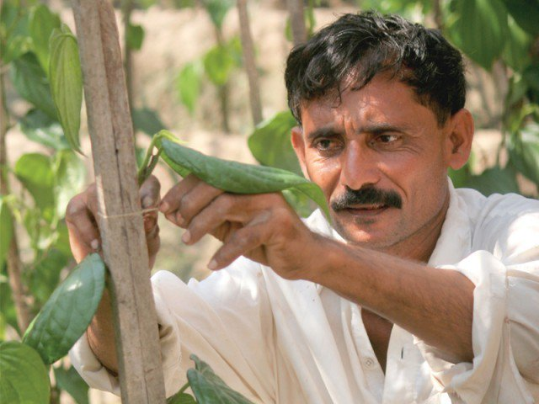

**RANA IBAD ALI**

**(37 years)**

**Farmer of Potato, Cabbage & Carrots**

**Land Ownership: 17 acres**

**Jahrowaal, Haveli Lakkha, Okara**

Rana Ibad, is value chain partner of our F2P project. He is a hardworking farmer believe in work with his own hands as he loves nature and farm vegetables. Rana Ibad is matriculate but have an acute interest in modern agricultural & farming practices. In winters, he cultivates Potato, Cabbage and Carrots and then shipped it to F2P warehouses as per the standards and SOPs agreed with Ibad and F2P. All these 3 vegetables are produced at Ibad’ land who cultivated it with his own hands.

You can also reach Rana Ibad directly at whatsapp: 0345 – 8550743